How to Access the Kids Chance of Nevada Application
www.kidschanceofnevada.org
Click on the Scholarship link, then Application. 
The website will direct you to sign up.
Click on “CREATE YOUR ACCOUNT”.
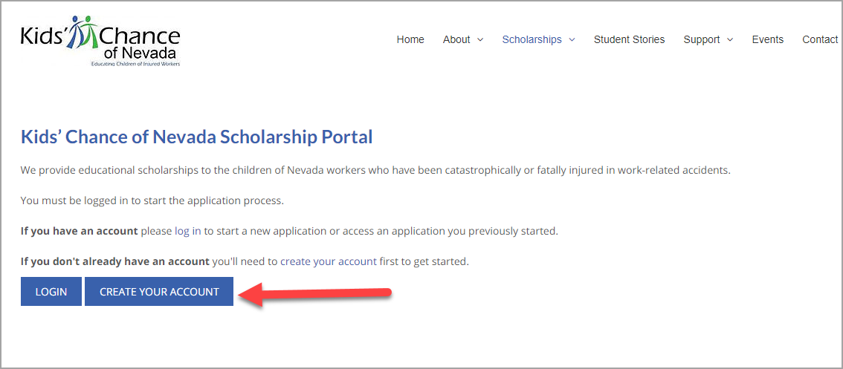
Complete all fields highlighted.
Click on Submit to complete your application.
